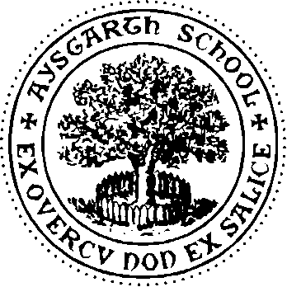

AYSGARTH SCHOOL TRUST LTD.

Founded in 1877, Aysgarth School provides its pupils with the opportunity to develop into confident, ambitious and resilient children who will thrive at Aysgarth, at their next school and in the wider world. With over 200 pupils in the school and a turnover just under £4.0m, the School supports a thriving community of both pupils and staff.
The School is located in Newton le Willows and set in 50 acres of rural North Yorkshire Dales with extensive facilities.

Aysgarth School is committed to safeguarding and promoting the welfare of children. Successful candidates must be willing to undergo full screening in accordance with Keeping Children Safe in Education (KSCIE), including an enhanced Disclosure and Barring Service check. Issues relating to safeguarding and promoting the welfare of pupils will be explored at interview

JOB DESCRIPTION – Finance Assistant (Full or part time)

Purpose of Job

Aysgarth School are looking for a Finance Assistant to support the existing Financial Department

The successful candidate should be skilled and knowledgeable in the area of Financial Management. Previous experience in schools would be an advantage, but not essential.

- To support both the Bursar and the Assistant Bursar in the compilation of meaningful financial information for the purposes of decision making.
- The preparation and maintenance of accounts and reports to enable the monitoring of expenditure by budget holders within the school and the production of accounts for monitoring against budgets and investigation of variances.

Key Responsibilities

- The production of termly fee invoices itemizing all termly charges based on information from teaching and boarding staff..
- Monitoring and recording of receipts from parents and the following up of late payments.
- Maintaining the purchase ledger including input of invoices and reconciliations and statements.
- Fortnightly BACS payment run for all suppliers and teachers expenses.
- Inputting details of invoices and payments to the computer under the appropriate nominal codes to enable the creation of termly accounts and annual accounts to trial balance stage. Maintaining the Nominal Ledger to produce termly accounts.
- Managing the monthly payroll, pensions and expenses process, ensuring that staff are paid on time and in full. Investigate pay queries.
- Production and submission of monthly and annual pension reports as required.
- Banking of monies received and maintenance of petty cash records and float managed jointly with the Assistant Bursar.

Special responsibilities

- Supporting and identifying improvement opportunities for the School’s finance and administrative systems.
- Administering Nursery Voucher scheme under NYCC guidance and regulations.
- Any other reasonable and relevant financial or administrative task.

Skills and knowledge required

A recognised accounting qualification with relevant experience in a similar roll.
.

Hours: Full or part time. The exact hours will be determined at the time of interview

Contract type; Permanent

Salary: Dependent on experience

Location: Newton le Willows, North Yorkshire, DL8 1TF

